2016 Event Schedule
Date and Time | Event | Location
2/27/16 at 7:30 pm | Lex. Chamber Chorale | Second Presbyterian Church
3/ 5/16 at 6 p.m. | Laskiainen | Gethsemane Lutheran Church
4/ 23 /16 at 6 p.m. | Danish Fare & Bus. Mtg. | Gethsemane Lutheran Church

VOLUME XLI
February 2016

Visit Us Online www.shsky.org

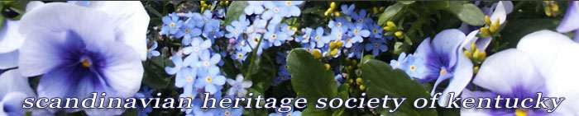
- Sign up for our mailing list and receive emails when new newsletters are available
- Join our Facebook page
- Check our Events page
- Contact us

SHSK Officers

President

Kristen Eubank

kristen.eubank@gmail.com

Secretary

Thomas Hakassson

natrix@mindspring.com

Treasurer

Anne Keating

(859) 537-6942

Newsletter Editor Anne Keating (859) 537-6942
Archivist

Craig Olson

(859) 252-2072

Fall Dinner at Spindletop

On October 17, 2015, SHSKY members and friends met at Spindletop for the annual dinner. It was a warm Indian Summer evening with good food, good company and excellent speakers! After dining on Chicken Bluegrass with ham and Swiss cheese, parslied new potatoes, haricots verts and cheesecake with fresh strawberries, Glenn and Kathy Blomquist spoke to us about their year in Latvia and experience in nearby countries Estonia and Lithuania, with slides to illustrate their talk. Russia has a presence on the Baltic sea, right below Lithuania and still tries to exert influence on that part of the world. We all learned a lot and so appreciate their sharing their experience with us!
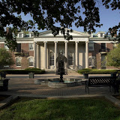

The Luciafest on cecember 12, 2015 was
LUCIA 2015

The Luciafest on December 12, 2015, was a great success by all accounts. Your editor was sorry to miss it. The enthusiasm of the participants and supporters creates a wonderful result. Thanks to everyone who contributed to the lovely evening! Please send me your favorite photos of the occasion for the next newsletter!

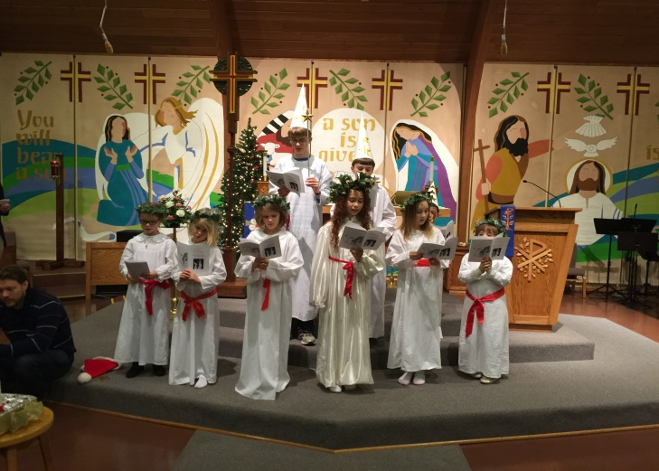
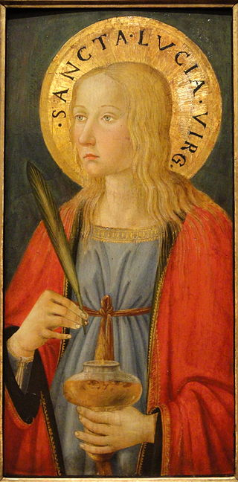

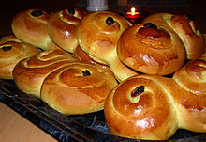
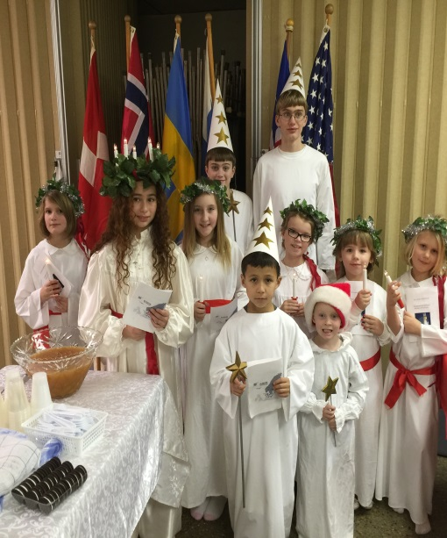
Scandinavian Heritage Society of Kentucky
Page 2

DIRECTOR & COMMITTEE
Kristie Eubank
Anne Keating

ACCOMPANIST
Kelly Peterson

NARRATOR
Thomas Hakansson

LUCIA
Layla Angeles Plakosh

PROCESSION
Emma Sophia Pousette
Edie Ingram
Signe Ingram
Savannah Peters

Jill Peterson
Isaac Angeles Plakosh
Christian Pousette
Theodore Ehrenborg
Thomas Ehrenborg
Gustav Pousette

CHORUS
Kristie Eubank
Stephanie Cooley
Kathy and Glenn Blomquist
Margaret Readdy
Richard Ehrenborg
Jaci Williams
Emily Montgomery
Monica Udvardy

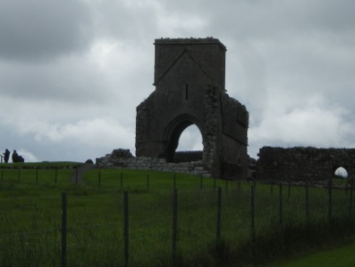

Thanks also to Dan and Jan Lindskog for making the Glogg, to Kristie Eubank and Jaci Williams and others who contributed to preparing the dining room and making it festive, and to all who brought decorations and the wonderful food to celebrate the occasion, and to all who helped to clean later and put the room back together again. Tack so mycket !

Scandinavian Heritage Society of Kentucky
Page 3

MUSIC IN THE LAND OF THE MIDNIGHT SUN
On Saturday, February 27, 2016 at 7:30, at Second Presbyterian Church, the Lexington Chamber Chorale will present a concert of Scandinavian music, combining some traditional Swedish folk songs with pieces by modern Swedish composers. Anders Astrand, a percussionist from Sweden, will be joining the group. Those members who remember the last concert by this group will know that this is an event not to be missed. Tickets will be available at the door or you can purchase them on line from the Lexington Chamber Chorale web page at www.lexingtonchamberchorale.org. Tickets are $20 or $15 for groups of 6 or more. You may want to get together before the concert. For more information, please visit the website, above, or the LCC Facebook page at www.facebook.com/The-Lexington-Chamber-Chorale-11634547 . . . .

Scandinavian Heritage Society of Kentucky
Page 4

We will celebrate Laskiainen this year on March 5, 2016 at Gethsemane Lutheran Church at 6 pm. This is the time we enjoy hearty pea soups which come in a surprising variety, accompanied by wonderful breads, crisp breads, pancakes, and great accompanying salads, vegetables and desserts. Do you remember which country eats yellow pea soup and the other predominately green? You may want to look at the event on Laskiainen sliding festival at Palo, Minnesota where they filmed the sliding down of a specially prepared chute with ice at the bottom to increase the ride! A narrator says that Laskiain. Means to slide, into Lent, into Spring . . . .Some people believed that the ride foretold the kind of flax harvest you would have. Take a listen! Some film clips from Finland show people of all ages taking sled rides, eating sausages and enjoying the snow! Our event is later than usual as we did not want to miss the concert! Don't these images make you want to visit Finland tomorrow!

LASKIAINEN

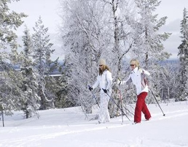
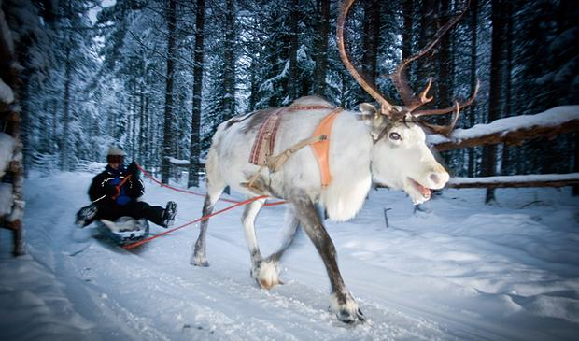

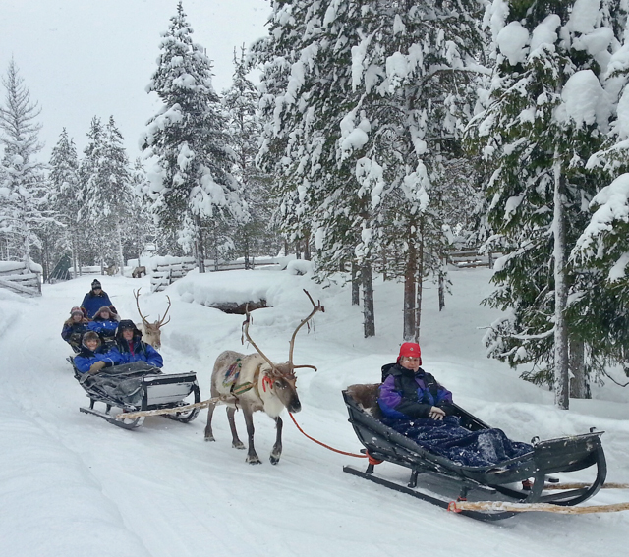
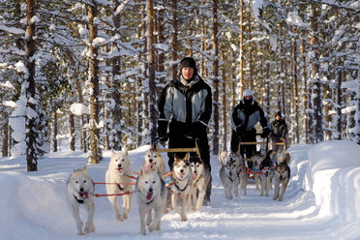

In Sweden, The Local lists 8 ways to enjoy their Frozen North:
- Walk on water. There is an ice trail where someone has recorded people skating, walking, biking, riding a skidoo and riding horses!
- Dog sledding. This appears to show the driver riding, which has always appealed to me if there are enough dogs to handle the weight!
- Visits to local historic churches
- Pack ice snowmobile safari in the Lulea Archipelago. Ice fishing is big!
- If you want R & R, the Jopikgarden Hotel is waiting for you.
- Musicians actually put on concerts on instruments made of ice. You need to check this out!

Scandinavian Heritage Society of Kentucky
Page 5

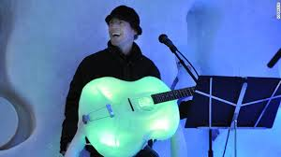
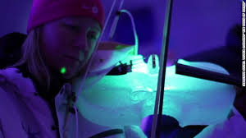

- Sports: ice hockey, of course!
- Foods from the frozen north.
Does this make you feel like a wimp? We need to see this place sometime!
Perhaps to fuel the energy for these activities we need to eat semlas, Swedish cream buns that are filled with almond paste and have plenty of whipped cream. A baker named Johansson has created one with gold leaf on top and champagne flavored whipped cream ($111) in response to a $100 gold donut created in New York City by the Manila Social Club! Traditionally, Semla are eaten only the date before Lent, sigh. I hope we may have some at our meeting!

Norway, too, has sea safaris where you see seals, puffins and eagles. You can stay in a lighthouse hotel at Brosundet, and the Oye mountains take your breath away. Time to start planning trips! There's so much to see in the world and so little time!

Iceland and Cher came to the rescue of Flint, Michigan which began using water from the Flint River instead of from Detroit's system to save money. Turns out the water had lead in it and that created many problems. Cher purchased Icelandic Glacial water from Iceland in huge quantities from Iceland and Icelanddic Glacial doubled the order!

We invite you to bring Danish food to the April meeting. One source says that the typical open faced sandwiches are on rye bread with: salami, liver pate, herring, roast pork, fried plaice, cod roe, cheese, chocolate or fruit! I know I have seen some with salmon, dill and cream cheese, and other combinations of vegetables and fruit. If you want to try it, let's mix it up! Dinner in Denmark typically consistnow of an appetizer, main cours and dessert. Vegetables include potatoes and other boiled vegetables. Meat may include meat ball,s cutlets or roast pork. The dessert most of us are familiar with is riz a l'amonde, or rice porriage with whipped cream, almonds and even cherry sauce.

Our next meeting will be the concert on February 27! Vi ses snart! (See you soon!)

Scandinavian Heritage Society of Kentucky
Page 6
Iceland and Cher came to the rescue of Flint, Michigan which began using water from the Flint River instead of from Detroit's system to save money. Turns out the water had lead in it and that created many problems. Cher purchased Icelandic Glacial water from Iceland in huge quantities from Iceland and Icelandic Glacial doubled the order!
We invite you to bring Danish food to the April meeting. One source says that the typical open faced sandwiches are on rye bread with: salami, liver pate, herring, roast pork, fried plaice, cod roe, cheese, chocolate or fruit! I know I have seen some with salmon, dill and cream cheese, and other combinations of vegetables and fruit. If you want to try it, let's mix it up! Dinner in Denmark typically consist now of an appetizer, main course and dessert. Vegetables include potatoes and other boiled vegetables. Meat may include meat balls, cutlets or roast pork. The dessert most of us are familiar with is riz a l'amonde, or rice porridge with whipped cream, almonds and even cherry sauce.
Our next gathering will be the concert on February 27, followed by the Laskiainen celebration on March 4! Vi ses snart! (See you soon!)
I have just learned that Lena Lee Renaker Price, age 90, mother of Annette Mathy, passed away on October 7, 2015. Mrs.Price was the co-owner and bookkeeper for KYVA Motor Company, and an organist! Annette we are so sorry for your loss.

